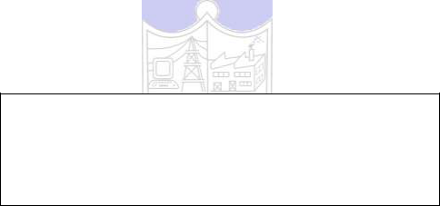

**Experiment No.3**

**Title:** Data analysis and classification using RapidMiner.

**Batch:** **Roll No.:** **Experiment No.:3**

**Aim:** To analyze the data and execute any two classification algorithms using RapidMiner

___________________________________________________________________________

**Resources needed:** Any RDBMS, Java/Python

___________________________________________________________________________

**Theory:**

Rapidminer is a collection of open source of many data mining and machine learning algorithms, including,

– pre-processing on data

– Classification

– clustering

– Association rule extraction

A dataset is a collection of examples, each one of class Instance. Each Instance consists of a number of attributes, any of which can be nominal (= one of a predefined list of values), numeric (= a real or integer number) or a string (= an arbitrary long list of characters, enclosed in "double quotes"). The external representation of an Instances class is an ARFF file, which consists of a header describing the attribute types and the data as comma-separated list.



**Rapidminer Main Features:**

Main features are as follows:

* 49 data pre-processing tools
* 76 classification/regression algorithms
* 8 clustering algorithms
* 15 attribute/subset evaluators + 10 search algorithms for feature selection.
* 3 algorithms for finding association rules
* 3 graphical user interfaces

**The Explorer (exploratory data analysis)**

Used for pre-processing, attribute selection, learning, visualization

**The Experimenter (experimental environment)**

Used for testing and evaluating machine learning algorithms

**The Knowledge Flow (new process model inspired interface)**

Used for visual design of KDD process

___________________________________________________________________________

**Procedure / Approach /Algorithm / Activity Diagram:**

1. Execute any two classification algorithms using RapidMiner tool
2. Analyze the results produced by Rapidminer

___________________________________________________________________________

**Results: (Program printout with output / Document printout as per the format)**



**Questions:**

1. List any five open sources / freeware tools available for data mining.

**Outcomes:**

___________________________________________________________________________

___________________________________________________________________________

___________________________________________________________________________

___________________________________________________________________________

**Conclusion: (Conclusion to be based on the objectives and outcomes achieved)**

___________________________________________________________________________

___________________________________________________________________________

**Grade: AA / AB / BB / BC / CC / CD /DD**

Signature of faculty in-charge with date

___________________________________________________________________________

**References:**

Books/ Journals/ Websites:

1. Han, Kamber, "Data Mining Concepts and Techniques", Morgan Kaufmann 3nd Edition



